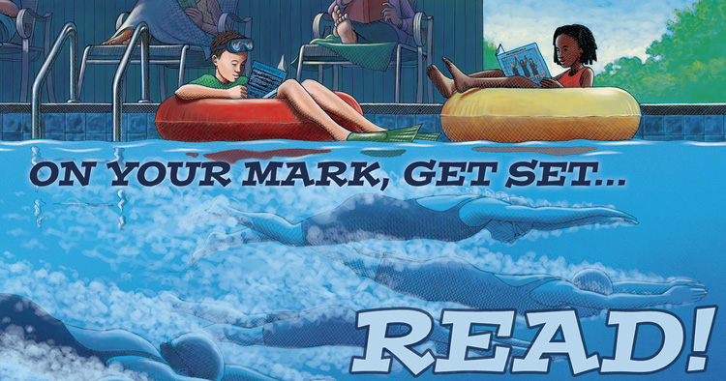

“One School, One Book” Summer Reading Assignment 2017-2018
Summer is here and it’s the perfect time to relax and read with your kids! Research shows that students who read a minimum of 4 to 6 books can maintain their reading skills and avoid the “summer slide,” a setback of one to two school months in reading and comprehension skills. Reading even more will improve their skills in preparation for the following school year.

In order to support summer literacy, Woodland School has once again implemented the One School, One Book initiative. Here is some important info:
• Our book selection is “Kid Athletes: True Tales of Childhood from Sports Legends” by David Stabler. This book was chosen by our students who had the opportunity to vote for one of three book choices. While the book does have a sports theme, it also promotes the importance of teamwork, overcoming obstacles, hard work and perseverance, themes which will carry over throughout the school year.
• We are asking all parents to have their children either read the book or have the book read to them prior to the beginning of the school year. All students are encouraged to have an understanding of the book realizing that not all students will be able to read the book alone. It is highly encouraged that parents read to and with their children.
• Books may be purchased through Amazon or from Barnes and Noble for approximately $13.95. Woodland School will have limited copies on hand which can be checked out during the summer at the Main Office for two week intervals. The entire Woodland team will be using the book throughout the school year and we encourage all students to have their own copy.

On your mark, get set, READ! Thank you for your continued support.

